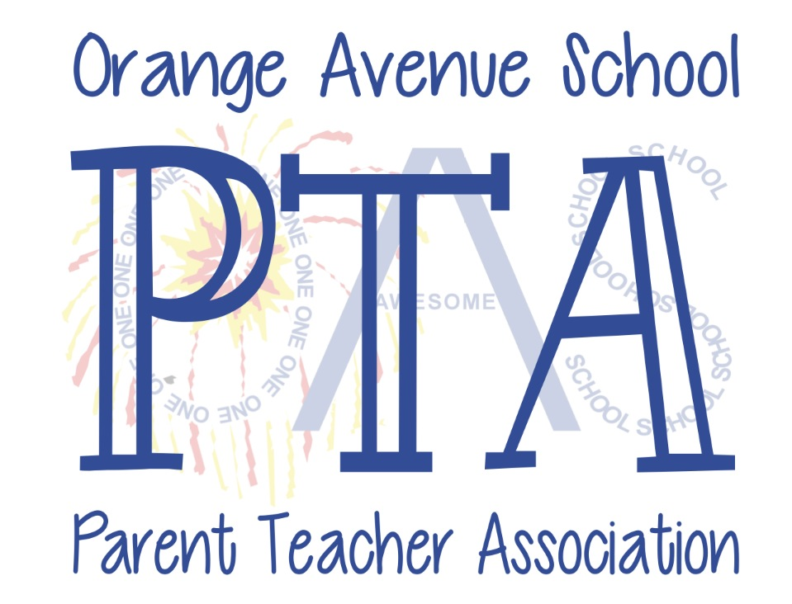

September 2020

Dear Orange Avenue School Families,

Welcome back! A strange welcome indeed, but welcome nonetheless. As school begins and we navigate this new territory, we want you to know that the OAS PTA is committed to our students, teachers, staff, administrators and community. We have been working hand in hand with the district throughout this ordeal and we all want our students to succeed. The PTA is here to help in any way we can, whether through needed classroom supplies, ‘assembly-like’ activities, social events (virtual or in-person) or other little things that may make the year a bit more pleasant for our kids.

Last year we were able to do a great deal with the help of monetary donations and helpful volunteers. We installed a large section of blacktop behind the school for recess and gym, gave close to $4,000 to teachers for use in their classrooms, funded two assemblies, purchased bike racks, landscaped our new sign and budgeted for several new enrichment activities. This year, we will need to be a little creative.

Now more than ever we need your support to be able to respond to the unique needs of our school. Please join the PTA! Follow the directions on our membership flyer (opposite side) to join and submit dues online or return the tear off portion and submit with your dues to the PTA lockbox at the main entrance to school. Your support is needed and appreciated. Join by September 25th and you’ll be entered into a raffle for a day at Great Adventure!

Also, please look for our weekly PTA Blast on Sunday nights, follow us on Facebook and check out the OASPTA.com website to stay up to date on events for the students and opportunities to get involved.

Again, welcome back, and we wish you and your children a great year!

Sincerely,
The OAS PTA Board 2020-2021
Co-Presidents: Jessica Kelly and BJ Canedo
Co-Vice Presidents: Lorian Morales and Liz Rivera
Co-Treasurers: Cori Jones and Sarah Morgan
Recording Secretary: Melanie Towne
Corresponding Secretary: Courtney Byrne

Attached: Break Away Lanyard for your child to use during ‘mask breaks’ courtesy of the PTA
Orange Avenue School PTA
2020-2021 Membership

Join the PTA and submit dues all through the MemberHub website. We have several levels to join…any donation above the $8 membership goes directly to our school. Thank you in advance!
- Request access to the OAS PTA MemberHub. Go to https://oasptacranford.memberhub.com/join/hg1h85
- Once your request has been approved, you will receive an email with next steps. Click on the link, create a password and a profile (your contact information for our directory) and you are in!
- Now you can join the PTA for the 2020-2021 year. Click on “SHOP” at the top of the page to join and submit dues online. You may need to toggle to the OAS page in your account (top right corner) if you were a member previously through another school.

For those who prefer a paper form for PTA membership, please fill out the following and submit with your dues to the PTA lockbox at the main entrance to the school. Thank you!
Members:
Member #1 _____________________________________________________________ $8
Email_______________________________________ Phone _________________________

Member #2_____________________________________________________________ $8
Email_______________________________________Phone__________________________

Donation: $_____________
(100% of donation goes directly to our school)

TOTAL ENCLOSED: (make checks payable to OAS PTA) $_____________
Student’s Name/homeroom___________________________________________________
Student’s Name/homeroom___________________________________________________

