“Dine out Tuesday”
At

1-7 South Ave West , Cranford NJ
(parking at the Cranford Crossing Garage)

10 % of your restaurant bill will be donated to
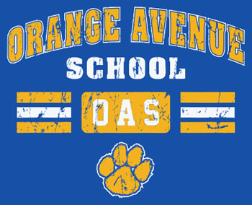
You Must bring this
flyer with you on
Tuesday, Feb 28th
available for lunch & Dinner
Please call 908-324-4140 to make a reservation
__________________________________________

Check # __________ # guests ________

Total Food and Beverage amount $ ________

