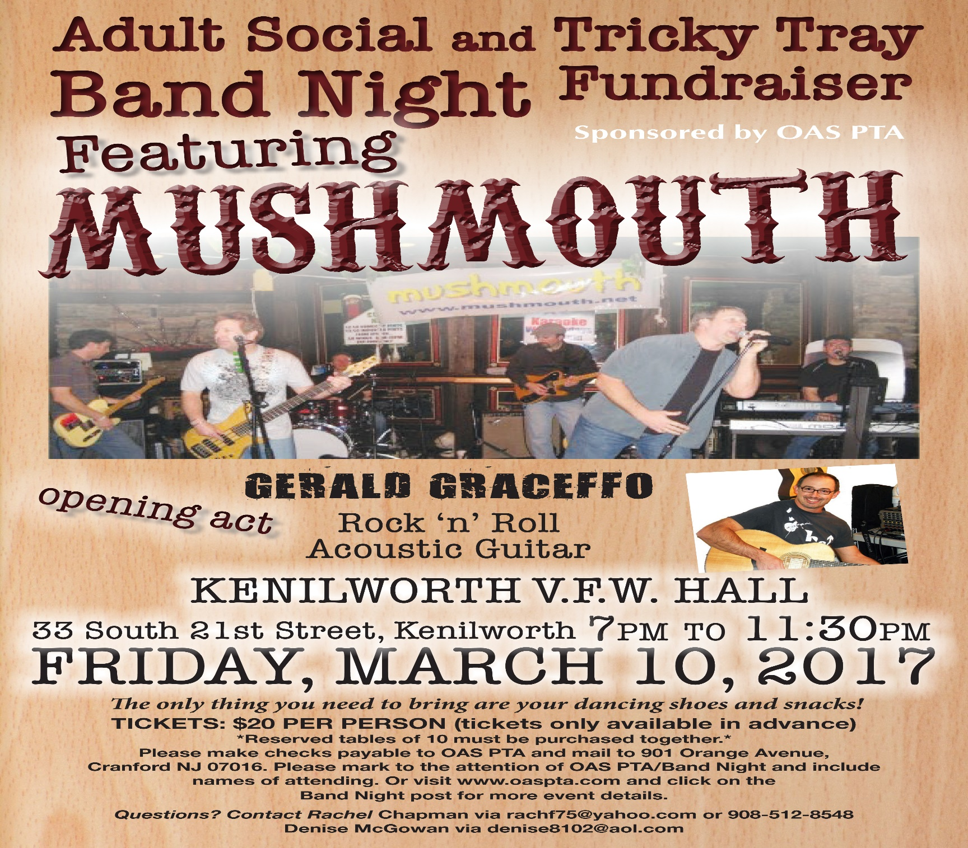

===================================================================================================
BAND NIGHT TICKET ORDER FORM
Don’t Miss Out! Order your tickets now!
# OF TICKETS ____X $20 = $____ (Mail checks payable to OAS PTA to 901 Orange Ave, Cranford, NJ 07016)

PLEASE LIST NAMES OF ALL ATTENDING: _____________________________________________________

_______________________________________________________________________________________
A LIMITED NUMBER OF RESERVED TABLES WILL BE AVAILABLE FOR ADVANCE PURCHASE. TABLES SEAT 10 AND TICKETS FOR ALL 10 ATTENDEES MUST BE PURCHASED IN ORDER TO RESERVE THE TABLE. PLEASE INDICATE, WHEN YOU RETURN THIS
FORM, IF YOU WISH TO RESERVE A TABLE. THERE WILL BE PLENTY OF OPEN SEATING AVAILABLE THE NIGHT OF THE EVENT.

PLEASE NOTE: YOU WILL NOT BE RECEIVING A PHYSICAL TICKET. UPON ARRIVAL PLEASE CHECK‐IN AT THE FRONT TABLE
For questions contact Rachel Chapman at rachf75@yahoo.com or Denise McGowan at denise8102@aol.com

